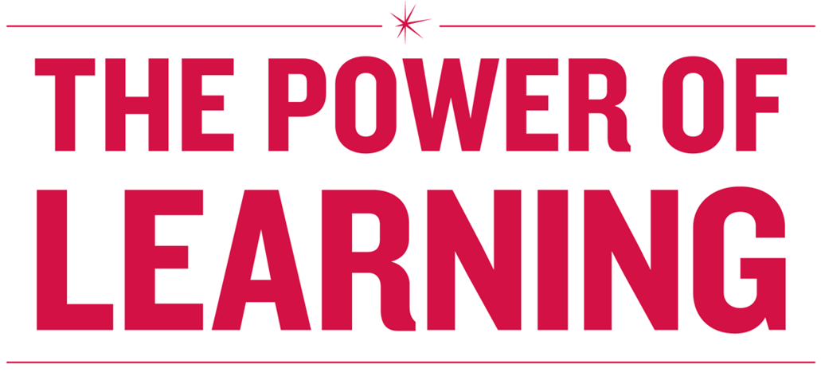

**POWER HOUR:**

**Rock Star Meetings**

# Lead, Coach, Manage

* Set challenging, but attainable, performance and behavior goals aligned with your business area goals and priorities.
* Provide real time feedback to your direct reports that is specific and actionable in order to influence the performance and behaviors required to be successful in the role.
* Use coaching to reinforce positive performance and behaviors and close performance and behavior gaps. Deliver difficult feedback directly and constructively.
* Hold regular 1:1s with direct reports to provide regular and objective feedback, seek progress on performance and development goals, discuss issues and challenges (yours and theirs) to achieving goals, and identify additional resources and support for employee success.
* Engage with your direct reports on their development; provide feedback on leadership competency progress and discuss all aspects of career and personal development—not just promotions (e.g. stretch assignments, On the Job Training and leadership development training that is planned or recently taken).
* Effectively use different rewards and incentives to drive performance.
* Create an environment that encourages the team to challenge the status quo; promote innovative ways of looking at problems and processes.
* Develop successors for key positions in your organization, including your own.
* Select the best talent for open positions (i.e. as good as or better than incumbent) and ensure their successful onboarding.

**Measures**

* Direct reports understand how their performance goals align with business objectives.
* Timely coaching and feedback is provided on a regular basis so direct reports know where they stand on performance goals, leadership competencies and development plans.
* Mid-year and Year-end performance discussions are meaningful and engaging with no surprises for the direct report.
* Performance feedback (e-Sup observations/coaching notes, mid-year, year-end reviews, leadership competency feedback, Performance Improvement Plans) is completed on time and with high quality.
* Employee Survey results show favorable and/or trending up, particularly Employee Engagement Index, Diversity Index and Supervisory Index.
* Team is making process improvements, sharing ideas and championing innovative approaches.
* Direct reports are sought after for other positions in the organization.

**Learning Objectives**

Upon completing this workshop, you should be able to:

### Identify the structure and important elements of successful meetings

* Identify different types of workplace meetings

### Learn best practices for meeting leaders, contributors, and facilitators

* Assess the quality of current meetings (purpose, agenda, participant’s energy and attention)
* Design and implement a meeting agenda
* Seek feedback on your meetings

**Agenda**

### Why Meet?

### Warm Up Activity

* 5 Steps to a Rock Star Meeting

### Prepare

* + Establish Ground Rules
  + Engage and Participate
  + Execute
  + Follow Through
* Monthly Operations Meeting Agenda
* Assess Your Current Meetings
* Design an Agenda

# **Warm Up Activity**

Discuss the questions below with your table group according to the role the facilitator assigns to you.

*If you’re a host, what do you think makes a meeting good for your participants?*

*What do you think makes a meeting bad?*

*If you’re a participant, what do you think hosts can do to make a meeting good or bad?*

Recall a meeting where you left having a real sense of accomplishment:

*What made it good for you individually?*

# **5 Steps to a Rock Star Meeting**

# **Prepare**

Use the following questions as a road map for your meeting agenda to develop a comprehensive meeting strategy.

1. **Is this meeting really necessary? Is there a business need to bring people together?**Do we need to:

* Share information that requires dialogue?
* Coordinate actions?
* Make decisions?
* Develop plans and strategies?

1. **What is the purpose of the meeting?   
   What do we want to be different because this group of people meets?**

* What tasks will be accomplished?
* What decisions will be made?
* What problems must be solved?
* What learning will occur?
* Who is responsible for implementation and follow through?

**3. What type of meeting does this need to be?**

* It is important to differentiate between types of meetings (page 7)
* Types of meetings vary in length and formality
* Create meeting agenda based on purpose, type of meeting, and who will be attending

1. **Who needs to be present?** **Include people who have:**

* Information
* Authority
* Responsibility for implementation or follow through
* Perspectives that will improve the outcome, decisions

1. **Develop a meeting agenda ahead of time. Include:**

* The purpose of the meeting and expected outcomes
* Date, location, duration
* A breakdown of each task by owner
* Next steps and action items
* Attachments and instructions for how to best prepare

1. **Prepare participants to actively participate and contribute to the meeting’s success**

* Involve people in the process of creating the meeting. This may be an opportunity to suggest agenda items, determine priority of topics, or assist in the general design of the meeting
* Communicate expectations for participation
* Communicate how decisions will get made

# **Prepare: Types of Meetings**

The key to successful meetings, according Patrick Lencioni, author of *Death by Meeting: A Leadership Fable* is to recognize that there are multiple types of meetings.

|  |  |  |  |
| --- | --- | --- | --- |
| **Meeting Type** | **Time Suggested** | **Purpose and Format** | **Keys to Success** |
| Chats, Huddles or  Daily Check-ins | 5 – 30 minutes | * To tackle a specific problem or issue * Usually an informal discussion | * Be conscientious of others’ time * Focus on the issue at hand * Ask for feedback |
| Weekly Tactical | 45-90 minutes | * Review weekly activities and metrics * Resolve tactical obstacles and issues | * Send out agenda in advance – keep reports about duties short * Postpone strategic discussions |
| 1:1 with Direct Reports | 30 minutes | * Support staff development * Track status of performance goals * Provide value-added feedback | * Provide direction and support but don’t micromanage * Prepare questions in advance to keep you on track with objectives and process |
| Monthly Operations or Town Halls | 2 – 4 hours | * Discuss, analyze, brainstorm, and problem solve critical issues affecting long-term success | * Limit to one or two topics * Prepare and do research * Engage in good conflict |
| Strategic: Quarterly,  Bi-annually, or Annually | 1 – 2 days | * Review strategy, industry trends, competitive landscape, key personnel, team development | * Get out of the office if possible * Focus on work * Don’t over structure the schedule |

*What other types of meeting tools are needed to host a successful meeting?*

# **Establish Ground Rules**

All teams have norms – the unwritten and written rules of how you can behave in meetings.   
Establishing norms with groups that frequently meet, helps to ensure there is a reliable process for getting work done together. Ground rules set the stage and expectations for each participant and allow everyone to maintain accountability for achieving the goals and purpose of each meeting.

Examples:

1. Share all relevant information
2. Everyone has a chance to speak without interruption
3. All ideas and opinions will be respected
4. All participants are invited to ask questions of an existing point of view
5. Before the meeting ends, the group will jointly design next steps and action items

MEETING DO’s and DON’TS:

Do:

* Arrive early
* Prepare
* Participate
* Help the meeting leader to achieve meeting goals
* Follow Up

Don’t:

* Arrive late
* Come unprepared
* User your phone or other devices
* Hold side bar conversations
* Challenge ideas, not people
* Listen to understand
* Be on time
* Create working agreements, refine later
* Humor helps
* Speak open & honestly & for yourself
* Unplug!

*What are some ground rules that you have found useful at your meetings?*

# **Engage & Participate: Roles and Responsibilities**

Below is an adapted list from the book *Let’s Stop Meeting like This* by David and Emily Axelrodof the different roles people can play in a meeting.

|  |  |  |
| --- | --- | --- |
| **Role** | **Responsibilities** | **Keys to Success** |
| Leader | * Creates a welcoming environment * Convenes the meeting * Assures that the purpose for the meeting is clear and compelling * Assures the right people are present * Leads the meeting, making sure the group stays on task * Facilitates dialogue related to the tasks | * Uses power wisely * Invites criticism * Mines for conflict * Makes sure the decision-making rules are clear * Is prepared for the meeting |
| Contributor | * Offers ideas and participates in discussion * Brings needed information to the meeting * Acts to facilitate the group’s work effectively | * Takes responsibility for the outcomes * Speaks openly and honestly * Remains open to others’ viewpoints * Prepares for the meeting in advance |
| Facilitator | * Assists the group in achieving its purpose * Promotes all participants’ voices * Helps to resolve conflicts | * Thinks like a designer – involves participants in the flow of the meeting * Describes what is seen and heard when impasses arise * Works to make sure everyone’s voice counts |
| Time-keeper | * Keeps meeting on track | * Provides 2-minute warnings |
| Minute-taker | * Records discussion of issues * Notes action items for each person * Composes meeting minutes * Sends out meeting minutes to participants after meeting * Makes any changes to meeting minutes as noted by other participants | * Beneficial to rotate this role for weekly tactical or monthly operational meetings * May be a good use of technology (e.g. computer, iPad, or other device) to keep track of minutes in an amended agenda |
| Presenter | * Researches and analyzes issues to be discussed during meeting * Presents information in an engaging fashion * Presents recommendations and suggestions for solutions | * Prepares for presentation * Distributes materials in advance of meeting * Invites feedback |

# **Execute**

**Reduce Distractions**

When participants enter a meeting space, it is likely they have just entered from doing other work or attending another meeting. It is easy for participants to become distracted and lose focus of the purpose for the meeting they are attending.

*What are some things that you have found helpful to do to maintain the focus of the group?*

**Maintain the Agenda**

* Welcome participants to the meeting and help them connect to the task of the meeting by introducing the agenda
* Confirm participant roles
* Post the established ground rules where everyone can see
* Be mindful of the agenda and timekeeping

**Communicate Expectations and How Make Decisions Get Made**

It is important to clarify, at the outset how decisions will get made. The meeting leader should:

* Communicate:
  + How decisions get made
  + What will be discussed
  + Who will make the decisions
  + When information will be shared

**Navigate Meeting Pitfalls**

Even when everyone is aware of their roles and responsibilities and there is a great facilitator to move the discussion forward – pitfalls, deadlocks, and impasses can happen in meetings.

*What have you found to be helpful to navigating out of meeting pitfalls?*

# **Execute: Navigating Meeting Pitfalls**

|  |  |
| --- | --- |
| **Problem** | **Helpful Action** |
| One person constantly talks | Paraphrase their message, ask for confirmation, and invite others to speak. |
| Two people argue while others remain silent | “I think we know your viewpoints.  I’d like to hear what others have to say.” |
| Two people are locked in conflict | Ask each person to state their understanding of the other person’s viewpoint. |
| The group is off on a tangent | “Let’s bring ourselves back to the focus…” |
| The group is deadlocked and unable to make a decision | “What would you like to do about the deadlock we are facing?” |
| You have an unclear understating of decisions reached or next steps | “I’m not clear on what we just decided” or “I don’t know what the next steps are, let’s get clear…” |

# **Follow Through**

Before ending the meeting, always leave time on the agenda to summarize. Remember to:

* Review any decisions made in the meeting
* Communicate how “open items” will be addressed
* Assign action items and to-do’s
* Create a road map to reach the next stage in planning your work
* Take time to reflect on your meeting and gather feedback about the meeting process

*What has been decided?*

*Who is responsible for carrying out the tasks or action items?*

*When is the due date for the action item or task?*

|  |  |  |  |  |  |  |
| --- | --- | --- | --- | --- | --- | --- |
| **Monthly Team Meeting** | | | **March 17, 2016** | | | |
| **8:30 – 10:00 AM** | | | |
| **LC3 1314** | | | |
| **Meeting called by:** | Jane Andrews, Director | | **Type of Meeting:** | Monthly – Operations | | |
| **Facilitator:** | Frank Davis | | **Note taker:** | Jose Garcia | | |
| **Timekeeper:** | Erika Reynolds | | | | | |
| **Attendees:** | Salma Cruise, Frank Davis, Jose Garcia, Andy, Jackson, Erika Reynolds | | | | | |
| **Please review:** | Attachments: Draft Evaluation Survey, Reporting Software New Requirements Meeting Agenda/Process | | | | | |
| **Please bring:** | Weekly Priorities & Issues, Hurdles & Opportunities | | | | | |
| **Agenda Items** | | | | | | |
| Topic | | | | | Presenter | Time allotted |
| * Welcome – Agenda Overview | | | | | Jane Andrews | 5 minutes |
| * Safety Message | | | | | Susan Reynolds | 10 minutes |
| * Highlights from last week? | | | | | Jane Andrews, All | 5 minutes |
| * Round Robin – Top 3 Priorities for coming month in 60 seconds | | | | | All | 10 minutes |
| * Issues: | | | | |  |  |
| * + Coverage for peak period and storm: June through August; Volunteers? | | | | | Salma Cruise | 10 minutes |
| * + New front line training program     - Launch date, enrollment report     - Manager communication templates     - Evaluation survey (input from team) | | | | | Andy Jackson | 15 minutes |
| * + Update and impacts of new software reporting system | | | | | Jose Garcia | 10 minutes |
| * To-Do’s: Actions/Owner/Deadlines & Deliverables | | | | | Frank Davis | 10 minutes |
| * Closing: Hurdles and Opportunities: Roundtable Discussion | | | | | All | 15 minutes |
| **Important Information** | | | | | | |
| Calendar: | April 7 2:00 – 3:30  LC2 106 | * Reporting Software New Requirements Meeting,  (see attached Six Thinking Hats Process, Goals and Agenda) | | | | |
| April 18 8:30 – 10:00  LC3 1314 | * Monthly Team Meeting | | | | |
| April 21 1:00 – 2:30  LC2 113/114 | * Road Show—Please make a strong showing! | | | | |
| May 27 | * Memorial Day Holiday | | | | |
| June 7 – 14 | * Andy on vacation | | | | |
| FYI: | June 21 – 25 | * Mid-year reviews due to Jane by 5 pm 6/25 | | | | |
| July 17 | * Employee Picnic at the Museum of Science and Industry | | | | |
| August 8 | * Charity Golf Event at Cantigny, see Frank to purchase tickets | | | | |

# **Activity: Assess a Meeting**

Take a moment to assess the last meeting you attended (as a leader, contributor, or facilitator) by answering the questions below:

Meeting Type: _________________ Length ____________________ Purpose: _________________

|  |  |  |  |  |
| --- | --- | --- | --- | --- |
|  | **Strongly disagree** | **Disagree** | **Agree** | **Strongly Agree** |
| The meeting agenda and materials were distributed prior to the meeting. |  |  |  |  |
| I was given ample time to review and prepare for the meeting. |  |  |  |  |
| The right people were included in the meeting. |  |  |  |  |
| I understood the meeting’s goal and purpose |  |  |  |  |
| I felt welcomed. |  |  |  |  |
| The meeting owner clearly communicated expectations of meeting participants. |  |  |  |  |
| I understood the ground rules for this meeting. |  |  |  |  |
| The group worked together to overcome impasses or conflict. |  |  |  |  |
| The meeting was free from distractions. |  |  |  |  |
| The decision making process was clear to everyone present. |  |  |  |  |
| I was clear on what actions were expected of me after the meeting. |  |  |  |  |
| The meeting provided valuable learning for me and the team. |  |  |  |  |
| The meeting strongly advanced the work of the organization. |  |  |  |  |
| What was the best part of the meeting? |  | | | |
| What was your least favorite part of the meeting? |  | | | |
| What can be done to improve this meeting? |  | | | |

When you have finished taking this assessment, discuss your assessment and what strategies may be taken to improve meeting planning, participation and results in the future.

# **Activity: Setting Your Agenda**

Using the template below as a guide, work with your partner or table group to draft a meeting agenda that improves on the meeting you assessed on page 16.

|  |  |  |  |  |  |
| --- | --- | --- | --- | --- | --- |
| **My Meeting** | | | **Date:** | | |
| **Time:** | | |
| **Location:** | | |
| **Meeting called by:** |  | | **Type of Meeting:** |  | |
| **Facilitator:** |  | | **Note taker:** |  | |
| **Timekeeper:** |  | | | | |
| **Attendees:** |  | | | | |
| **Please review:** |  | | | | |
| **Please bring:** |  | | | | |
| **Agenda Items** | | | | | |
| Topic | | | Presenter | | Time allotted |
| * Welcome – Agenda Overview | | |  | |  |
|  | | |  | |  |
|  | | |  | |  |
|  | | |  | |  |
| * Issues: | | |  | |  |
|  | | |  | |  |
|  | | |  | |  |
|  | | |  | |  |
| * To-Do’s: Actions/Owner/Deadlines & Deliverables | | |  | |  |
| * Closing: Hurdles and Opportunities: Roundtable Discussion | | |  | |  |
| **Important Information** | | | | | |
| Calendar: |  |  | | | |
|  |  | | | |
|  |  | | | |
|  |  | | | |
|  |  | | | |
| FYI: |  |  | | | |
|  |  | | | |
|  |  | | | |

# **Final Debrief**

What 1-2 things are you taking away that you can use in your work?

How might others know that you took this training?

# **Appendix A: Sample Team Meeting Agenda** (Source: manager-tools.com)

|  |  |  |  |  |  |  |
| --- | --- | --- | --- | --- | --- | --- |
| **My Meeting** | | | | **Date:** | | |
| **Time:** | | |
| **Location:** | | |
| **Meeting called by:** |  | | | **Type of Meeting:** |  | |
| **Facilitator:** |  | | | **Note taker:** |  | |
| **Timekeeper:** |  | | | | | |
| **Attendees:** |  | | | | | |
| **Please review:** |  | | | | | |
| **Please bring:** |  | | | | | |
| **Agenda Items** | | | | | | |
| Topic | | | Presenter | | | Time allotted |
| * Welcome – Agenda Overview | | |  | | |  |
|  | | |  | | |  |
|  | | |  | | |  |
|  | | |  | | |  |
| * Issues: | | |  | | |  |
|  | | |  | | |  |
|  | | |  | | |  |
|  | | |  | | |  |
| * To-Do’s: Actions/Owner/Deadlines & Deliverables | | |  | | |  |
| * Closing: Hurdles and Opportunities: Roundtable Discussion | | |  | | |  |
| **Important Information** | | | | | | |
| Calendar: |  |  | | | | |
|  |  | | | | |
|  |  | | | | |
|  |  | | | | |
|  |  | | | | |
| FYI: |  |  | | | | |
|  |  | | | | |
|  |  | | | | |

# **Appendix B: Meeting Effectiveness Assessment**

|  |  |  |  |  |
| --- | --- | --- | --- | --- |
|  | **Strongly disagree** | **Disagree** | **Agree** | **Strongly Agree** |
| The meeting agenda and materials were distributed prior to the meeting. |  |  |  |  |
| I was given ample time to review and prepare for the meeting. |  |  |  |  |
| The right people were included in the meeting. |  |  |  |  |
| I understood the meeting’s goal and purpose |  |  |  |  |
| I felt welcomed. |  |  |  |  |
| The meeting owner clearly communicated expectations of meeting participants. |  |  |  |  |
| I understood the ground rules for this meeting. |  |  |  |  |
| The group worked together to overcome impasses or conflict. |  |  |  |  |
| The meeting was free from distractions. |  |  |  |  |
| The decision making process was clear to everyone present. |  |  |  |  |
| I was clear on what actions were expected of me after the meeting. |  |  |  |  |
| The meeting provided valuable learning for me and the team. |  |  |  |  |
| The meeting strongly advanced the work of the organization. |  |  |  |  |
| What was the best part of the meeting? |  | | | |
| What was your least favorite part of the meeting? |  | | | |
| What can be done to improve this meeting? |  | | | |
| What role would you like to play in a future meeting (e.g. timekeeper, minute-taker, presenter? Other? |  | | | |

# **Appendix C: Bibliography and Additional Resources**

* Axelrod, Richard H., and Emily M. Axelrod. Let's Stop Meeting like This: Tools to save Time and Get More Done. San Francisco: Berrett-Koehler, 2014. Print.
* Gannon, Mary Lee. "Seven Killer Ground Rules for Effective Meeting Facilitation." Starting Over Now's Blog. StartingOverNow.com, 21 Feb. 2010. Web. 18 Feb. 2016.
* Grove, Andrew S. High Output Management. New York: Random House, 1983. Print.
* Kohen, Nancy. "Half of All Meetings Are Unproductive. Is There a Fix?" Half of All Meetings Are Unproductive. Is There a Fix? Marketplace, 24 Sept. 2013. Web. 10 Feb. 2016.
* Lencioni, Patrick. Death by Meeting: A Leadership Fable-- about Solving the Most Painful Problem in Business. San Francisco, CA: Jossey-Bass, 2004. Print.

[Free Management Library](http://managementhelp.org/)

Provides free, easy-to-access, online articles. Over the past 15 years, the Library has grown to be one of the world's largest well-organized collections of these types of articles and resources.

[AxelrodGroup.com](http://axelrodgroup.com/)

Research, articles, blogs and insights from authors, Emily and Dick Axelrod

[TableGroup.com](http://www.tablegroup.com)  
Resources for team building, leadership, and employee engagement.

[Manager-tools.com](http://www.manager-tools.com)    
An online resource that provides podcasts, templates and tools for manager development.

[The](http://lms.exeloncorp.com/plateau/user/deeplink_redirect.jsp?linkId=ITEM_DETAILS&componentID=E-W-ALL-SITLEAD0304&componentTypeID=TRAINING&revisionDate=1415818380000) Art and Science of a 1:1 *at ComEd*

This two-hour workshop gives managers and supervisors tools to become skillful and effective communicators and coaches with their direct reports, colleagues and bosses. The workshop reviews best practices and tools for conducting a 1:1 meeting for employee development.

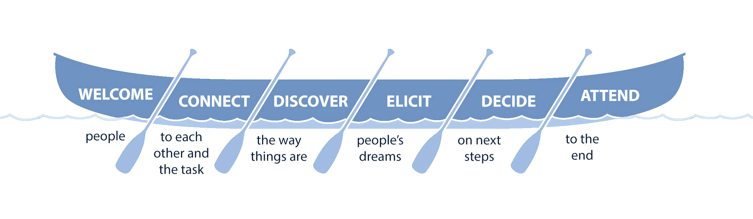

The Meeting Canoe, Richard & Emily Axelrod